SIMATS ENGINEERING (SAVEETHA SCHOOL OF ENGINEERING)
Department of Computer Science and Engineering
ASSESSMENT TOOL 2 – Pseudocode Writing Task

Course Code: | CSA06 | Course Title: | Design and Analysis of Algorithms
CO Assessed: | CO5 – Naturalization (BL5, BL6) | Assessment: | Assessment Tool 2 – Pseudocode Writing Task
Weightage: | 30% of CIA | Total Marks: | 100
CO5 Statement: | Analyze computational problems using backtracking techniques and complexity classes such as P, NP, NP-Hard, and NP-Complete for combinatorial problem solving.
Student Name: | S Suvikumar | Reg. No.: | 192424262
Section / Batch: | AI&DS | Date:

Instructions to Students
• Answer ALL questions with proper pseudocode and logical explanation.
• Clearly specify the algorithmic approach and complexity class wherever applicable.
• Use proper asymptotic notation (Big-O, Big-Θ, Big-Ω) for complexity analysis.
• Include state-space representation, recursion steps, and pruning conditions in backtracking problems.
• Neat presentation and step-by-step justification are mandatory.

Question Type | Focus Area | Questions | Marks
Pseudocode Writing Task | Analyze combinatorial problems using backtracking and complexity classes such as P, NP, NP-Hard, and NP-Complete. | Q1 – Q3 | Q1 –40  Q2 –30  Q3 -30
GRAND TOTAL: |  | 100 Marks

SECTION A – Pseudocode Writing Task
Q58. Subset Generation with Size Constraint
Write a pseudocode using Backtracking to generate all subsets of size k from a set. Clearly define inputs (set, k) and output (subsets). Design an algorithm that includes or excludes elements recursively. Use loops for subset construction. Apply pruning when subset size exceeds k. Present structured pseudocode. Ensure all valid subsets are generated.
Q59. N-Queens with Blocked Cells
Design a pseudocode using Backtracking to place N queens on a board with blocked cells.Clearly identify inputs (board, blocked positions) and output (valid placements). Develop analgorithm that checks row, column, diagonal, and blocked constraints. Use recursion effectively. Apply pruning to avoid blocked positions. Ensure clarity and correctness. Handle all configurations.
Code of Conduct
I __________________________ (Name / Reg No) certify that this submission is my original work and that I have adhered to the guidelines specified for this assessment. I understand that any violation of academic integrity rules will result in disciplinary action.
Signature of the Student: _________________________
RUBRICS FOR CALCULATION
Criteria | Weightage | Level 4 – Exemplary | Level 3 – Proficient | Level 2 – Developing | Level 1 – Beginning
Problem Understanding | 20% | Identifies all inputs, outputs, constraints accurately | Minor missing elements | Partial understanding | Incorrect interpretation
Algorithm Design | 30% | Complete, correct, and logically sound solution | Minor logical gaps | Partially correct logic | Incorrect approach
Use of Control Structures | 20% | Efficient and appropriate use of loops, conditions, functions/modules | Minor inefficiencie s | Limited or basic usage | Incorrect or missing constructs
Pseudocode Structure | 10% | Well-structured, clear, consistent format, easy to follow | Mostly clear with minor issues | Difficult to follow in parts | Poorly structured and unclear
Completeness | 20% | Handles all cases; optimized approach | Handles most cases; reasonable efficiency | Handles basic cases only | Incomplete or inefficient
Marks Evaluation:
Question No. | Problem Understanding  (20%) | Algorithm Design  (30%) | Use of Control Structures  (20%) | Pseudocode Structure  (10%) | Completeness  (20%) | Total Marks (Each – 50)
Q1
Q2
Q3
Overall Total (100)

Faculty In-charge | Course Coordinator | Head of Department
Signature: _______________ | Signature: _______________ | Signature: _______________
Date: ___________________ | Date: ___________________ | Date: ___________________

58
Aim
To generate all subsets of size k from a given set using the Backtracking technique with pruning.

Algorithm
- Read the set elements and value of k.
- Start with an empty subset.
- Recursively include or exclude each element.
- If the subset size becomes greater than k, prune that branch.
- If the subset size equals k, store and display the subset.
- Continue until all elements are processed.
- Print all valid subsets of size k.

Code
def generate_subsets(arr, k, index, current):
if len(current) == k:
print(current)
return
if index == len(arr):
return
# Include current element
current.append(arr[index])
generate_subsets(arr, k, index + 1, current)
# Exclude current element
current.pop()
generate_subsets(arr, k, index + 1, current)
arr = [1, 2, 3]
k = 2
print("Subsets of size", k, ":")
generate_subsets(arr, k, 0, [])

Output
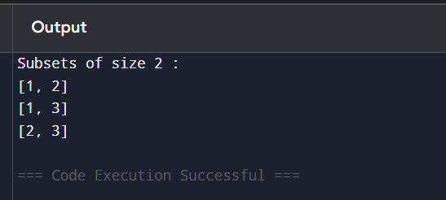

Result
Thus, all valid subsets of size 2 were successfully generated using the Backtracking technique with pruning.

59
Aim
To place N queens on an N × N chessboard containing blocked cells using Backtracking while satisfying row, column, diagonal, and blocked-cell constraints.

Algorithm
- Initialize an N × N board.
- Mark blocked cells.
- Start placing queens row by row.
- Check whether a queen can be placed:
  - Cell is not blocked.
  - No queen exists in the same column.
  - No queen exists on either diagonal.
- If safe, place the queen and move to the next row.
- If no safe position exists, backtrack.
- Continue until all queens are placed.
- Display the valid board configuration.

Python Code
N = 4
board = [['.' for _ in range(N)] for _ in range(N)]
# Blocked cell
blocked = {(1, 1)}
def is_safe(row, col):
if (row, col) in blocked:
return False
for i in range(row):
if board[i][col] == 'Q':
return False
i, j = row - 1, col - 1
while i >= 0 and j >= 0:
if board[i][j] == 'Q':
return False
i -= 1
j -= 1
i, j = row - 1, col + 1
while i >= 0 and j < N:
if board[i][j] == 'Q':
return False
i -= 1
j += 1
return True
def solve(row):
if row == N:
return True
for col in range(N):
if is_safe(row, col):
board[row][col] = 'Q'
if solve(row + 1):
return True
board[row][col] = '.'
return False
if solve(0):
print("Valid Placement:")
for row in board:
print(" ".join(row))
else:
print("No Solution")

Output
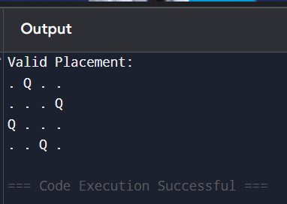

Result
Thus, the N-Queens problem with blocked cells was successfully solved using Backtracking, ensuring that all queens satisfy row, column, diagonal, and blocked-cell constraints.

